Software Engineering Assignment 3
Name: SHRAVAN SAPATE Roll No: 27
UID: 23016027 CSBS 2nd year Date: 1-OCT-2024

Case Study: Application of Object-Oriented Programming Principles in Contemporary Software Engineering
Overview
Object-Oriented Programming (OOP) has established itself as a fundamental approach to developing software that is scalable, maintainable, and highly reusable. By leveraging core principles such as encapsulation, abstraction, polymorphism, and inheritance, developers can design systems that are modular and more manageable. These principles enhance code maintainability and allow for greater flexibility, making it easier to adapt and extend software as requirements evolve.
Example 1: Modularity in Android Application Development
Modularity refers to the practice of breaking down a software system into self-contained, loosely coupled units or components. Each module focuses on a specific functionality, reducing the overall complexity of the system and simplifying both its development and maintenance.
In the Android ecosystem, Google advocates for developers to adopt a modular approach when designing apps. This promotes a cleaner codebase, facilitates code reuse, and allows for independent updates and testing of different parts of the application.
- Componentization: Android applications are typically structured into multiple modules such as user interface (UI), data management, and networking, which enhances clarity and maintainability.
- Reusable Components: Developers often create reusable libraries or SDKs that encapsulate specific functionalities. These libraries can then be easily integrated across different projects, promoting code reuse, and reducing duplication of effort.
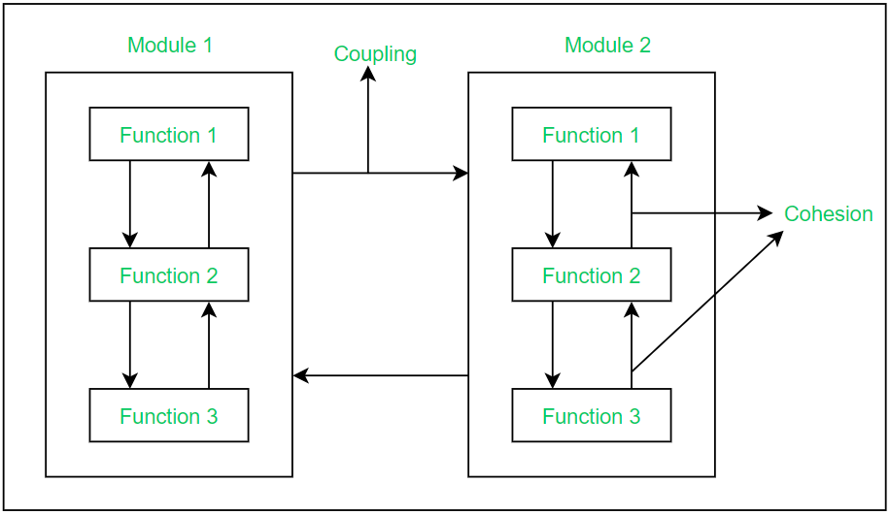


Example 2: Encapsulation and Information Hiding in Cryptographic Systems (IBM)

Encapsulation refers to the process of grouping together related data (attributes) and the functions (methods) that operate on them within a single unit, typically a class. This principle also emphasizes protecting the internal details of a class from the outside world while providing a controlled interface for interaction. This control over access leads to a more organized, modular, and secure code structure.
In the realm of cryptography, IBM utilizes encapsulation and information hiding to enhance security. By safeguarding cryptographic processes, they ensure that encryption keys are securely transmitted and managed throughout the system.

- Encapsulation: Key generation and distribution algorithms are housed within secure modules, which contain the critical data required for managing cryptographic operations. By keeping these operations within secure, encapsulated components, the risk of exposing sensitive data is minimized.

- Information Hiding: IBM ensures that sensitive details, such as encryption keys and cryptographic techniques, remain protected from unauthorized access. This measure is critical in preventing potential attacks and protecting the system from exploits that could compromise security.

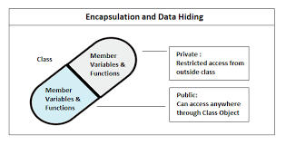


Use Case 3: Abstraction in Amazon Web Services (AWS)

Abstraction: is a key principle in software engineering that simplifies complex systems by exposing only the most necessary and relevant components to the user, while hiding the underlying technical details. This enables users to interact with sophisticated systems without needing to understand the complexities that operate behind the scenes.
Amazon Web Services (AWS) exemplifies abstraction by shielding developers from the intricate aspects of infrastructure management. This allows them to concentrate on application development without being encumbered by details like server configurations or network management.
- Abstraction:
AWS Lambda, a serverless computing platform, embodies the concept of abstraction by eliminating the need for developers to manage servers. Developers simply upload their code, and AWS handles everything from scaling to load balancing, making server management invisible to the user.

- User-Friendly Interface:
AWS enhances ease of use through its AWS Management Console, which provides an intuitive interface for managing cloud resources. This abstraction simplifies cloud operations, allowing users to control complex infrastructure without needing to engage with the technical details.

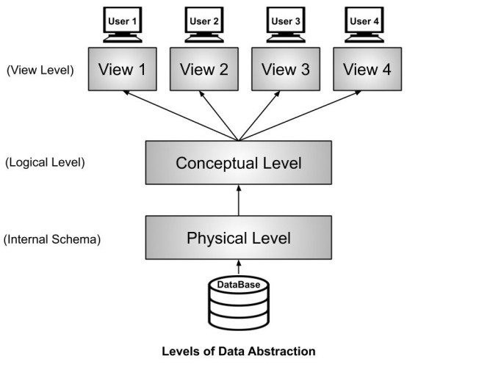

Conclusion:

Through the lens of Android development, IBM's cryptographic systems, and Amazon Web Services, we can clearly see how key Object-Oriented Programming (OOP) principles enhance software development by promoting modularity, security, and simplicity. Each of these cases demonstrates how OOP concepts can be effectively applied to solve distinct challenges in modern software systems:

Modularity in Android development enables developers to break down large applications into independent, reusable components, improving both maintenance and scalability.

Encapsulation and Information Hiding in IBM's cryptographic systems protect sensitive data and secure key management processes, minimizing exposure to potential vulnerabilities.

Abstraction in AWS simplifies cloud infrastructure management, allowing developers to focus on application logic without needing to manage underlying server configurations.

As software development continues to evolve, these OOP principles will remain central to creating scalable, secure, and user-friendly solutions. By leveraging these concepts, developers can streamline their processes and build software that adapts to changing technological landscapes.

